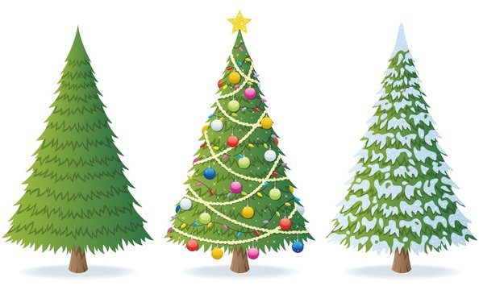
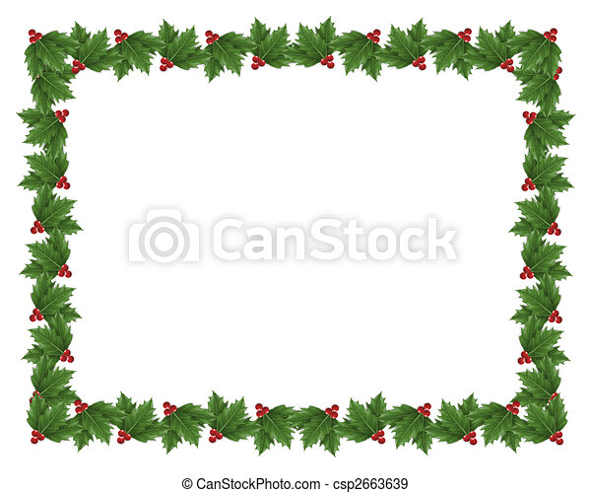
1.25 – 1.50MT £27
1.50 – 1.75MT £32
1.75 – 2.00MT £38

Norway Spruce

